Sending Docusigns

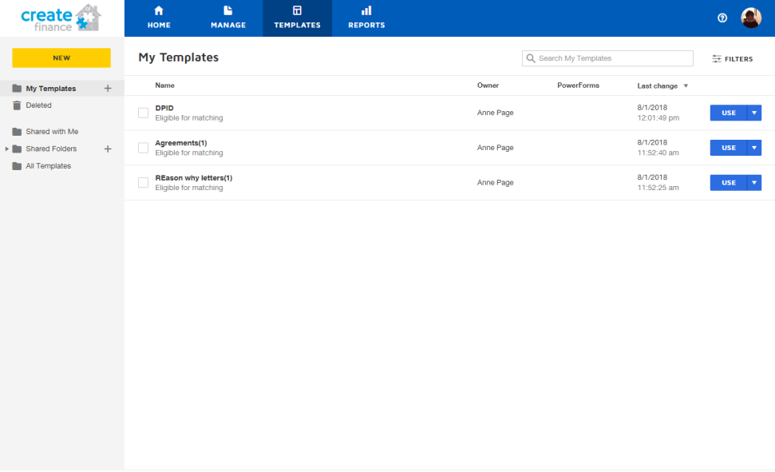
When you log on to docusign click on ‘Templates’ and ‘My templates’.
Your templates should then be visible to you – Find the one you need and click use.

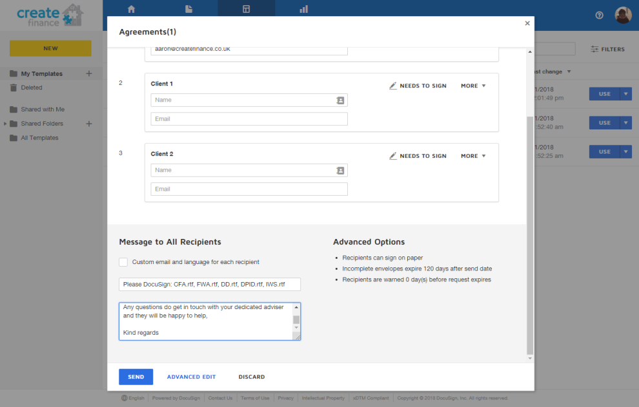

Once you click ‘Use’ this box should come up, you then need to click ‘Advanced Edit’

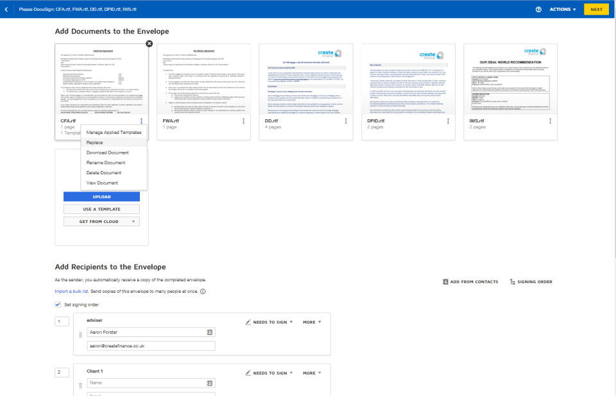
After that this screen should show. As this is a template it will have documents which are not for the client which are you going to send the agreements to. So, click on the three dots at the bottom of the document, select replace, locate the client’s folder and select the correct document you need to send. This should then replace it, do the same for other documents and delete any you do not need.

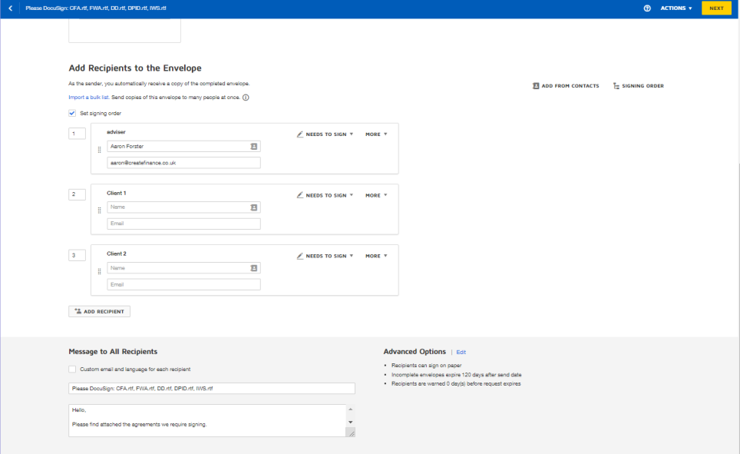
After you have sorted out all the agreements needed scroll down and input the clients’ name and emails. Edit the subject to the agreements you are sending and type the email.

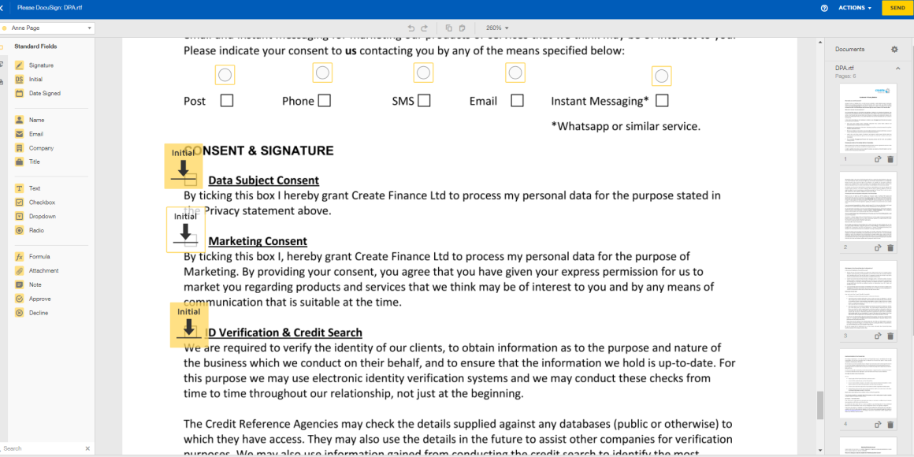
After that, click next and ensure all the signings are in the correct place and send!

